Antcor IkarusOS

Compex is proud to announce that Compex WP54 is now able to run IkarusOS. Loading the IkarusOS into the AP is simple. First you need to visit Antcor’s website, http://www.antcor.com/ac/cdownloads to download the image files for Compex WP54. After that, follow the instructions below to load in the Antcor IkarusOS.
Step 1:
Click on Firmware Upgrade from the SYSTEM TOOLS menu.
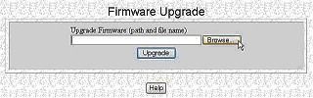

Step 2:
Click on the Browse button to locate the image file that you downloaded from Antcor’s website .
Step 3:
Click on the Upgrade button.
Follow the instructions given during the upgrading process.
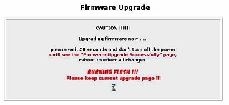
Step 4:
You need to reboot the system after the firmware upgrade.
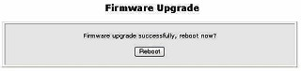

 | NOTE  1. The firmware upgrade process must NOT be interrupted otherwise the device might become unusable.  2. You would no longer be able to use Compex GUI after upgrading to IkarusOS. Please make sure you can ping to 192.168.1.3 (IkarusOS default IP)
To be able to manage WP54 with IkarusOS, you would have to download the IkarusOS Manager on http://www.antcor.com/ac/cdownloads. For more details, please refer to IkarusOS User Guide available on the same webpage.

